Conference Title
- subtitle -
XX. Moving Anthropology Student Network Conference
Dates, Location

Application  form for presenters | 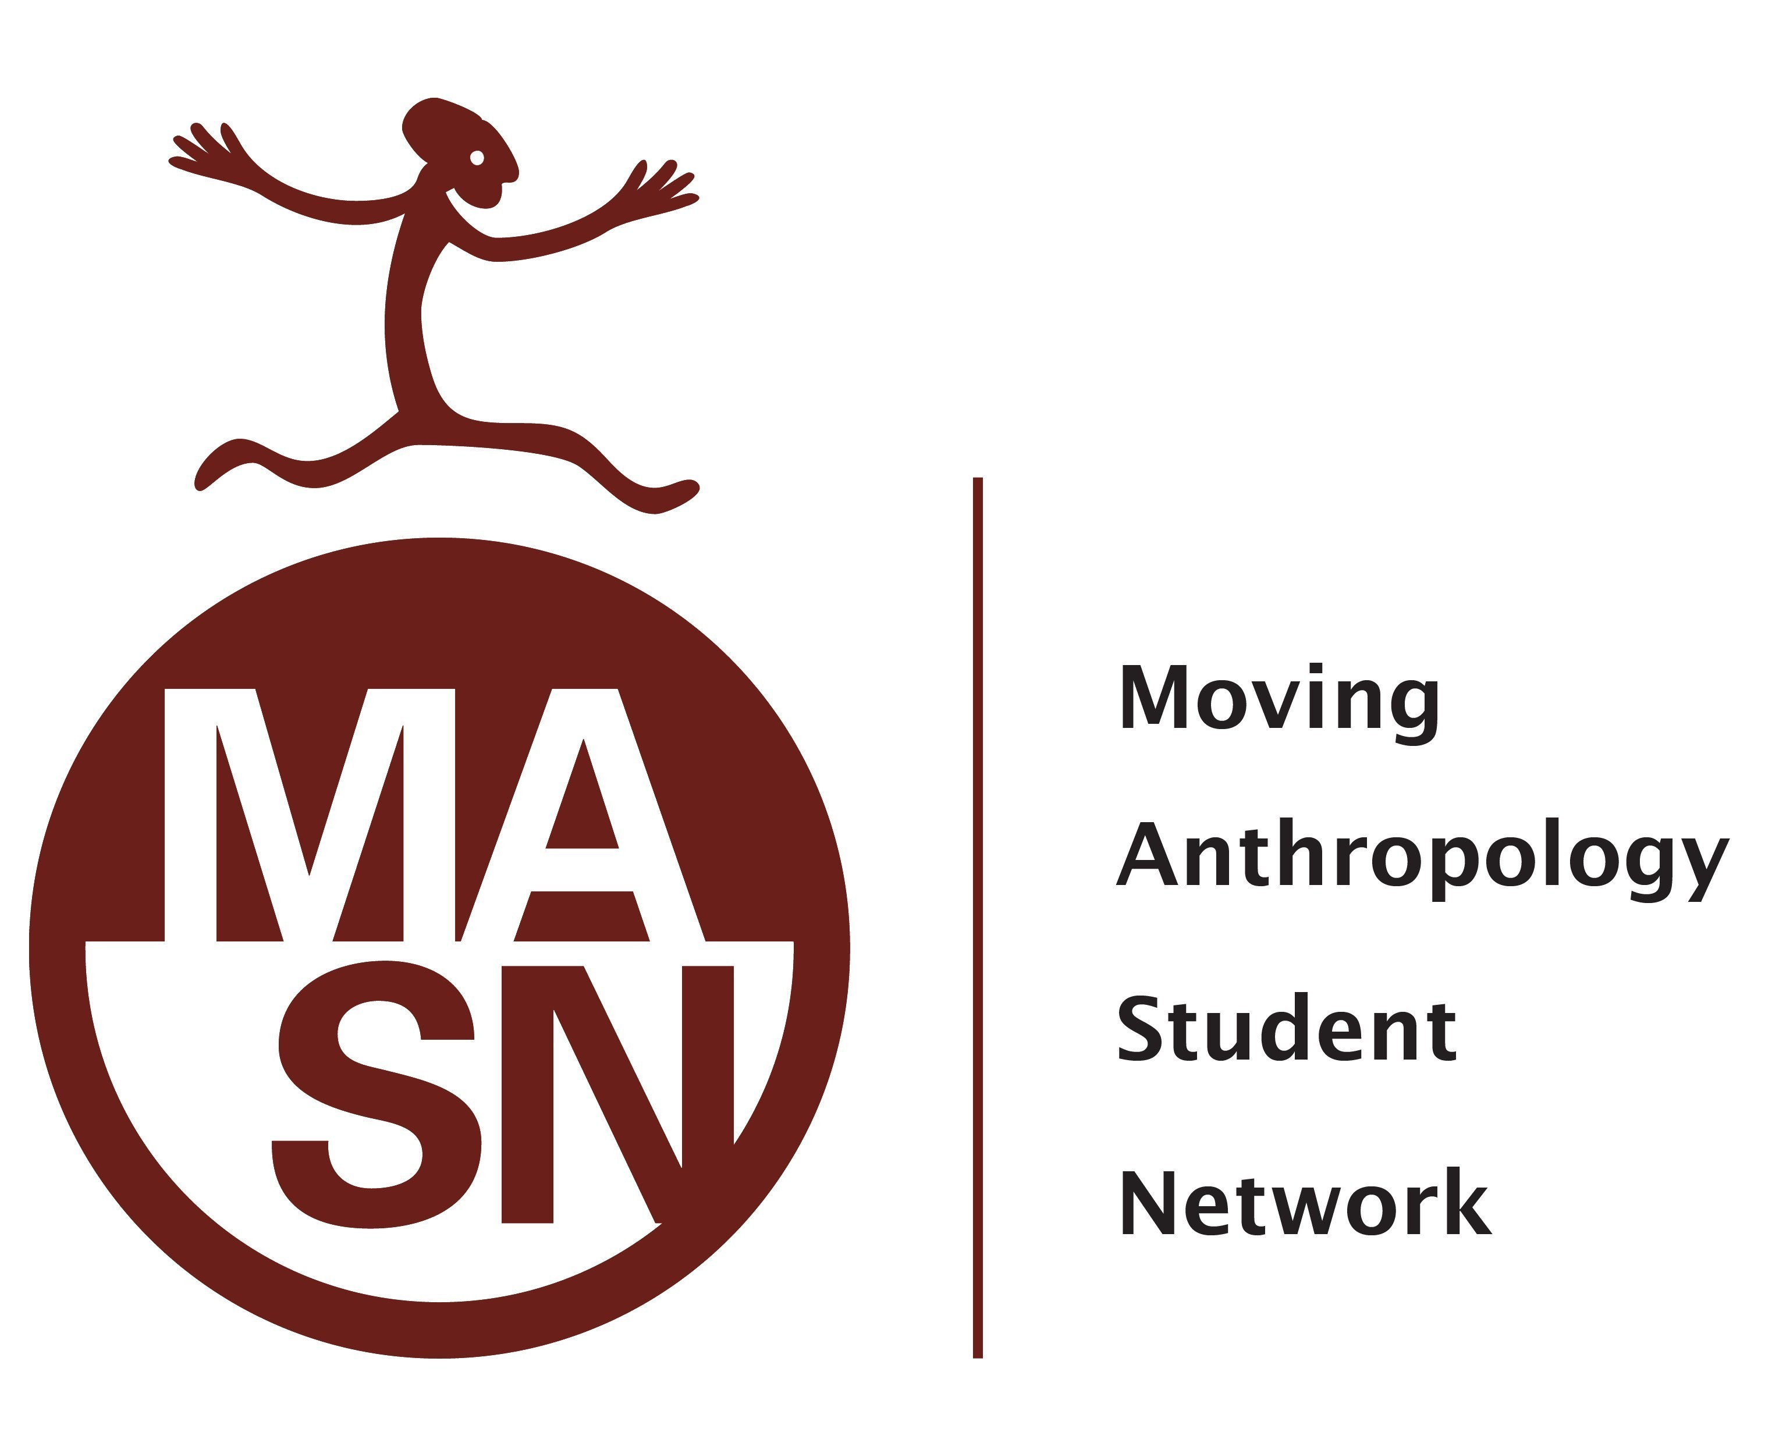

Person #1:
Name:
Cell No.: | Email:
Address:
Date of Birth: | Degree in Anthropology:

Ads: (City; Code): | State:

University / Department/ Institution:

Topic:

I/we intend to submit a paper
I/we intend to moderate a roundtable discussion
I/we intend to propose a concept for a workshop
I/we intend to enrich the conference with a fringe event
I/we plan to ….

Technical or other sorts of equipment (if needed):

ABSTRACT (max. 300 words):

If you need anything else, please let us know as soon as possible.
Please return this application form to E-MAIL ADDRESS until the DATE.
We are looking forward meeting you!
All the best!
MASN conference team

